Section-A
1.
a) What do you mean by statistical data? What are the sources of statistical data? Distinguish between primary and secondary data.
Solve:
Statistical data is information that is collected and organized to help us understand and describe different aspects of the world. It involves numbers, facts, or figures that can be analyzed to draw conclusions or make predictions. This kind of data is used in various fields, such as science, economics, and social research.

There are two main sources of statistical data:

Primary Data:
This is information that is collected firsthand directly from the source. For Example you want to know how many people in your school like pizza. If you go around and ask each person individually, the answers you get would be primary data. Primary data is fresh and specific to your particular study or investigation.

Secondary Data:
This is information that has already been collected by someone else for a different purpose. Using the pizza example again, if you find a survey conducted by your school last year about student’s favorite foods and use that information, it becomes secondary data for your study.

b) What is central tendency? What are the measures of central tendency? Show that "Sum of the deviations from arithmetic mean is zero".
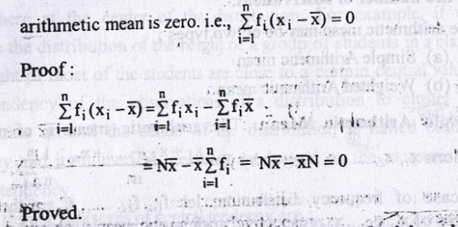

c) For two non-zero positive observations show that AM ≥ GM ≥ HM

2. a) What do you mean by dispersion? What are the important measures of dispersion? Define standard deviation and CV.
b) If x̄ and σ denote respectively the mean and standard deviation of a set of n observations, then show that $\bar{x} \sqrt{\left(n-1\right)}$ ≥ σ.
c) Calculate the mean, standard deviation and CV from the given data:
20, 26, 40, 36, 23, 42, 35, 24, 30, 32.

3.
a) Define (i) Sample Space (ii) Random Experiment (iii) Probability of an Event. 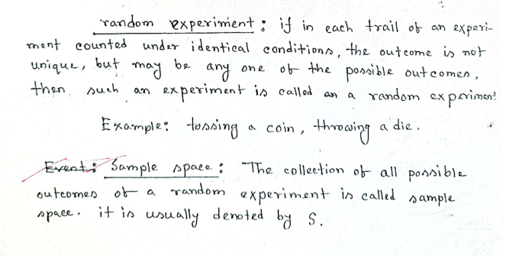
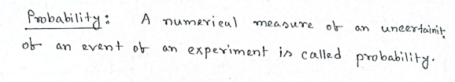
Solve:

(b) Three events A₁ A₂ and A₃ are mutually exclusive and their union is the sample space S. If
P(A₁) = $\frac{3}{2}$ P(A₂), P(A₂) = 2P(A₃) then find P(A₁), P(A₂), and P(A₃).

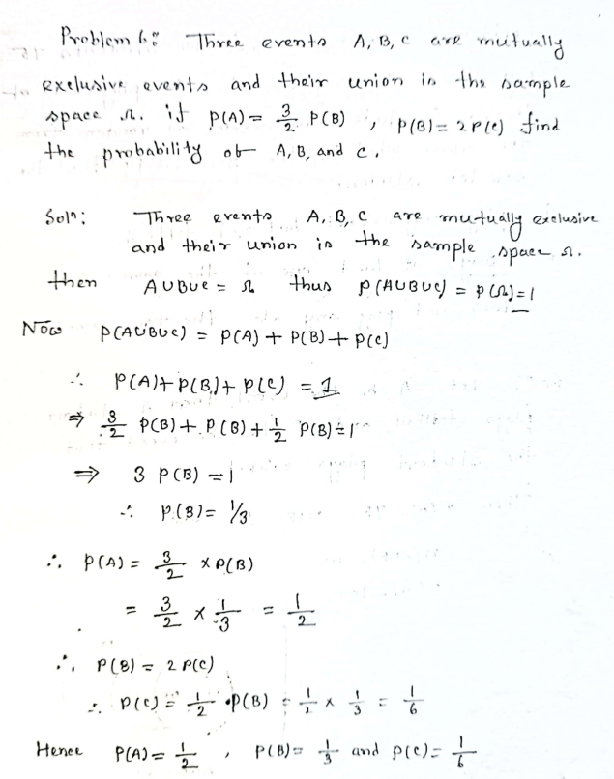
(c) Write down the probability mass function of Poisson distribution. Find the mean and variance of Poisson distribution. Hence show that mean and variance of the distribution are equal.
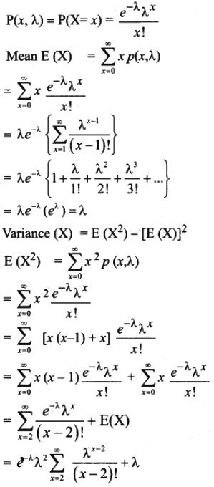
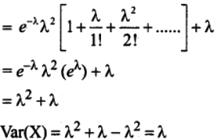

Section-B

4. (a) What do you mean by scatter diagram? Define Pearson correlation coefficient. Mention the important properties of correlation coefficient.
(b) Show that correlation coefficient lies between -1 and +1. If X and Y are independent then show that they are uncorrelated.
(c) Calculate the correlation coefficient between temperature (x in K) and pressure (y in atm) of a certain gaseous product and interpret the result:
x | 298 | 301 | 302 | 310 | 312 | 323 | 337 | 341 | 349
y | 1.2 | 1.3 | 1.5 | 1.7 | 1.8 | 2.0 | 2.1 | 2.3 | 2.8

5. (a) What do you mean by a simple linear regression model? Distinguish between correlation and regression.
(b) Prove that the regression coefficient is independent of origin but not of scale.
(c) GPA (x) and the corresponding starting salary (y) in thousand were as follows:
x | 3.26 | 2.60 | 3.35 | 2.86 | 3.82 | 2.21 | 3.47 | 3.28 | 2.54 | 3.25
y | 33.8 | 29.8 | 33.5 | 30.4 | 36.4 | 27.6 | 35.3 | 35.0 | 26.5 | 33.8
Estimate the least squares prediction equation of y on x. Find the starting salary corresponding to each of the GPAs 2.75 and 3.75.

6. (a) Define (i) Type-1 Error (ii) Type-II Error (iii) Level of Significance (iv) Power of a Test.
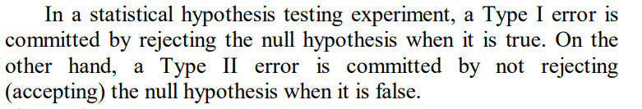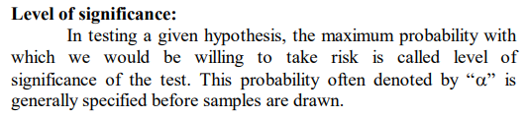
The power of a statistical test is the probability of correctly rejecting a false null hypothesis. It represents the ability of the test to detect a true effect or difference when it exists.

(b) A random sample of 15 men from a community yields a mean height of 67.6 inches. The value of standard deviation from the sample is 3.4 inches. Do the data support the hypothesis that the mean height of men in that community is 65.8 inches? [t_{0.05, 14} = 2.145]

(c) Define 2×2 contingency table? For 2x2 contingency table, show that X² =$\frac{N(ad-bc)² }{(a+b)(c+d)(a+c)(b + d)}$

